Merry Christmas 2020 from the Plotzski’s

Dearest family/friend…Insert your name here
What a year for the Plotzski Family! We didn’t want to quarantine apart, so we’ve got all the kids at home—so much for an empty nest. Here’s our update…
First, the kids…
- Nicole is considered an “essential” worker at the Cartel Pharmaceutical Company. We were very worried about her, but she tells us that her PPE actually makes her job easier.
- Dolores was planning to get married to the fella she met last year on Farmersonly.com. However, with the Covid and all, she and her fella had a quick ceremony at the justice of the peace. Mary “zoomed” the ceremony, hope you were able to watch it. Dolores and her fella are expecting a little farmer fella any day now and we just can’t wait.
- The twins—they’re still not growing, but they are excelling at remote learning. They have perfect attendance records and since they don’t like to go out of the house, remote school suits
them just fine. We haven’t been getting any e-mails about bullying this year, so that’s been a relief. Still, cute as buttons don’t cha think?

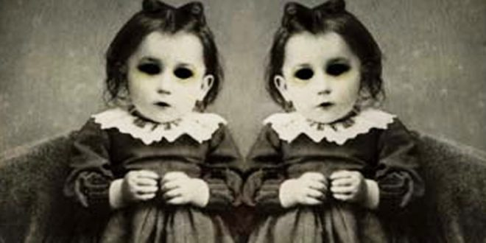
4/5. Jeremy is off of parole and moved to Montana to help Hunter out with the Hunting Lodge. They both are doing very well and have added some kind of garden out there. They have been able to help us out with bills since we both have lost our jobs due to this Covid thing. They also brought home all the toilet paper that was at the lodge and boy, was that a blessing. Glad to have them home, too, but I don’t remember either of them being so paranoid, even when Jeremy was on parole. Oh well, it’s crazy times, so that might have something to do with it.
6. We included Aunt Jenny in our quarantine bubble. She lives alone and we were really afraid she would be lonely. It’s been a bit difficult as she refuses to wear a mask, but social distancing from her has really been no problem. Plus, the twins just love her.
Since we have not been working, we have been trying to keep busy with projects around the house. Sam’s honey-do list keeps growing as he does not put the handy in handyman. Mary still enjoys baking, but she couldn’t find any yeast and bought a lifetime supply of the stuff on Amazon. She’s been able to bring in a little money selling her edibles. Every little bit helps this year.
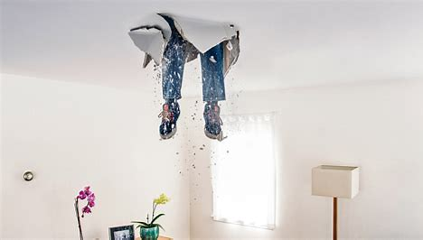
Well, that’s us. We hope you are well and happy and we would love to hear from you.
Sincerely,
Sam, Mary, Nicole, Dolores, the Twins, Jeremy, Hunter Plotzski and Uncle Jenny

